Instructions:
- Complete a case analysis of Tesla (Case 18) in the case section of the text.
A formal, in-depth case analysis requires you to utilize the entire strategic-management process. Assume your group is a consulting team asked by Tesla to analyze its external/internal environment and make strategic recommendations. You will be required to make exhibits to support your analysis and recommendations. The case analysis must encompass 10-12 pages plus the exhibits, cover page, and reference page. The cover page must include the company name, your group name, and the date of submission.
The completed case must include:
* Make sure the entire document is formatted the same. (Font, spacing, APA, etc.)
* Executive Summary: - In Process
This section should be completed last and encompass the very brief summary of the entire case study. This should focus on the true plan for suggested strategies. Make the reader want to find out more!
* Existing mission, objectives, and strategies - In Process
* A new mission statement: - In Process
Build upon the original and be sure to include all criteria suggested by our text.
* SWOT (TOWS) Analysis: - In Process
* Competitive Profile Matrix - Completed
* EFE Matrix - Completed
* IFE Matrix - Completed
* List alternative strategies for the company -Need Help
* Recommend specific strategies and long-term objectives: - Need Help
This is where you will actually say which of the strategies you have chosen for the company and why. Include major and minor objectives for the plan, and criteria for evaluation. – This professor likes numbers, percentages, and etc.
The book also considers Step 9 Recommend specific strategies and long-term objectives. Show how much your recommendations will cost. Clearly itemize these costs for each projected year. Compare your recommendations to actual strategies planned by the company.
***NEED TO INCLUDE OUTSIDE REFERENCES and BOOK REFERENCES***
If you provide the link for the references that are listed within the page. I can do the reference page.

List of alternative strategies: 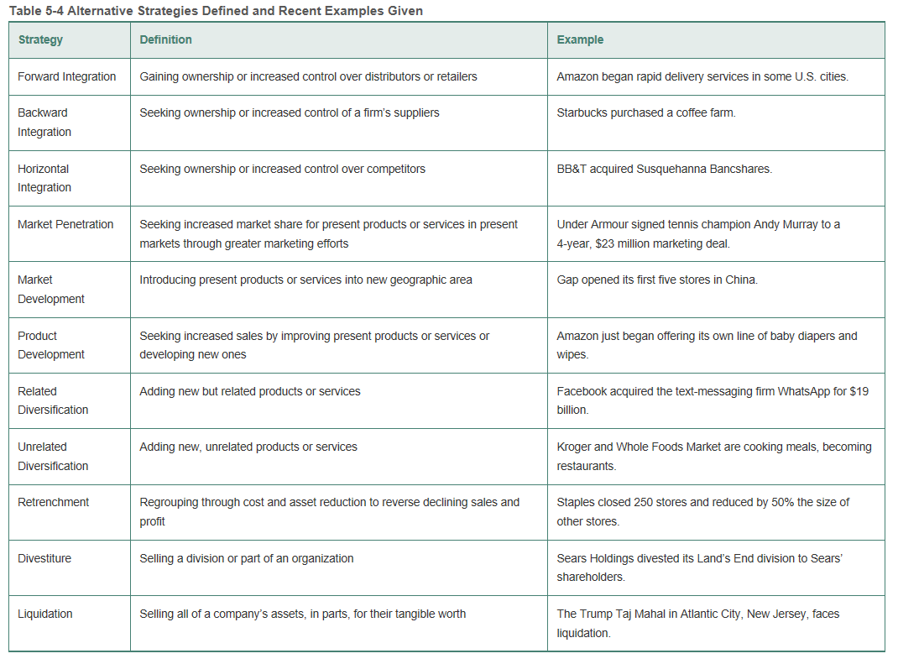

See Next Page for Case

David, Fred R. Strategic Management, 16th Edition. Pearson, 2017
p. 516

Tesla Motors, Inc., 2015
www.teslamotors.com, TSLA
Headquartered in Palo Alto, California, Tesla Motors designs, develops, manufactures, and sells fully electric vehicles and advanced powertrain components. Well known for its one-of-a-kind Roadster sports car vehicle, Tesla operates 80 dealerships and galleries in North America, Europe, and Asia, and sells vehicles directly from the corporate website.
During Q4 of 2014, Tesla introduced an all-wheel drive Model S, produced a record 11,627 vehicles, delivered 9,834 vehicles, and announced that its new Model X would ship in 6 months. However, the company’s Q4 performance fell far short of expectations because Tesla’s net income for Q4 decreased 561.8 percent, compared to the same quarter a year earlier, falling from –$16.26 million to –$107.63 million. Tesla’s net operating cash flow decreased to –$86.40 million or 166.58 percent, compared to the same quarter the prior year. Furthermore, the company reported a steep decline in earnings per share to $2.36, versus –$0.71 the prior year. Tesla attributed the poor performance to bad weather, shipping problems, currency headwinds, and customer vacations that prevented planned deliveries.
As of February 19, 2015, Tesla’s stock was trading at $211.71, up 27.4 percent below its 52-week high of $291.42, and 19.5 percent above its 52-week low of $177.22. Investors are nervous about Tesla’s future, due to the (1) impact of lower gasoline prices on customer demand, (2) speed with which the company can ramp up production, (3) high value of the dollar, and (4) company’s primary interest in growing market share at the expense of profitability.
In August 2015, Reuters’ analysis revealed that Tesla was actually losing more than $4,000 on every model S Sedan sold as the company reported operating losses of $359 million during the second quarter of 2015. Tesla’s losses are beginning to worry analysts. However, CEO Elon Musk has promised to deliver profits by the first quarter of 2016 and is looking to expand Tesla’s energy storage business. The company’s model S Sedan sold a mere 11,532 vehicles during the second quarter of 2015, but the company is planning to launch its Model X SUV in September 2015. Tesla still says it will deliver 500,000 autos by 2020, but critics are skeptical. A bright spot for the company is the grid battery business, dubbed “Tesla Energy,” that may provide future profit. Shares of Tesla in August 2015 sold for $241, having dropped about 9 percent in the last 30 days.

History
Founded in 2003 by a group of engineers, Jeffrey Straubel, Elon Musk, and Marc Tarpenning, Tesla manufactured its first electric vehicle, the Tesla Roadster, in 2008. The vehicle offered instant torque, incredible power, and zero emissions. The Roadster featured a sports car powertrain built around an AC induction motor, patented in 1888 by Nikola Tesla, the inventor who inspired the company’s name. The Roadster accelerates from 0 to 60 mph in 3.7 seconds and has a range of 245 miles per charge of its lithium ion battery. To date, Tesla has sold more than 2,400 Roadsters, now on the road in more than 30 countries.
In 2012, Tesla launched a fully electric sedan named the Model S, with room for seven passengers and more than 64 cubic feet of storage. The Model S provides the comfort and utility of a family sedan while achieving the acceleration of a sports car: 0 to 60 mph in about 5 seconds. With a range of 265 miles per charge, the Model S was named Motor Trend’s 2013 Car of the Year and achieved a 5-star safety rating from the U.S. National Highway Traffic Safety Administration.
In late 2014, Tesla released its two dual-motor, all-wheel drive configurations of the Model S, named the P85D and featuring a high-efficiency motor at the front and rear. The P85D can achieve a 0 to 60 mph time of 3.2 seconds—the fastest four-door production car ever made. With more than 50,000 vehicles on the road worldwide at year-end 2014, Tesla is preparing to launch Model X, a cross-over vehicle that enters volume production in 2015. For long-distance journeys, Tesla’s Supercharger network provides convenient and free access to high-speed charging, replenishing half a charge in as little as 20 minutes. Superchargers now connect popular routes in North America, Europe, and Asia Pacific.

p. 517

Internal Issues

Vision/Mission/Values
Tesla has an elaborate code of business conduct and ethics posted at the corporate website. Its mission is to “accelerate the world’s transition to sustainable transport.”

Organizational Structure
As illustrated in Exhibit 1, Tesla uses a functional organizational design, with no apparent divisions, no COO, and no women among top management.

Exhibit 1 Tesla’s Organizational Structure
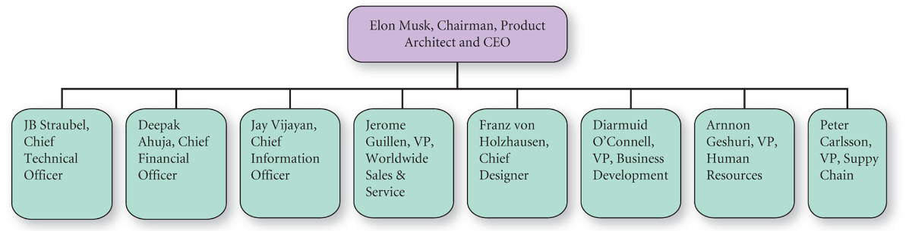
Source: Based on the author’s depiction given current executives listed at Tesla’s corporate website.
Description
A flowchart of an organizational chart. There are 2 levels in the flowchart. Moving from top to bottom, level 1 is Product Architect and CEO; level 2 includes Chief Technical Officer; CFO; CIO; VP, Worldwide Sales and Service; Chief Designer; VP, Business Development; VP, Human Resources; VP, Supply Chain.

Manufacturing
Tesla produces up to 1,000 vehicles per week at its factory in Fremont, California, but the company is building additional manufacturing facilities in Tilburg, the Netherlands, where it has an assembly facility, and Lathrop, California, where it has a specialized production plant. Along with partners such as Panasonic, Tesla is building a Gigafactory near Reno, Nevada, that will produce a mass-market affordable vehicle, named the Model 3. By 2020, the Gigafactory will produce more high-tech lithium ion cells than all of the world’s combined output in 2013. The Gigafactory will also produce battery packs intended for use in stationary storage, helping to improve robustness of the electrical grid, reduce energy costs for businesses and residences, and provide a backup supply of power. The Gigafactory reveals that Tesla is not just an automaker but a technology and design company with a focus on energy innovation.

Strategy
In 2014, Tesla increased its number of dealerships and service centers by over 40 percent, expanded its Supercharger network by 400 percent, started construction of the Gigafactory, and introduced numerous advances on Model S. The company entered 2015 with over 10,000 orders for its Model S and almost 20,000 reservations for its Model X.
In Q4 of 2014, Tesla built 11,627 vehicles, achieving its production target of 35,000 Model S vehicles for the entire year. The company launched the Model S P85D in November 2014. Motor Trend called this vehicle the “quickest sedan in the world” and a YouTube video of thrilled passengers went viral.
Tesla has started selling vehicles in Australia, and four other countries/regions, doubling its number of sales and service locations internationally. Tesla remains convinced that China is a key country for the company, and thus is simplifying the buying process in China by having Tesla personnel install charging points at customer homes or businesses well before vehicle delivery.
In Q4 of 2014, Tesla installed a quarterly record 125 Supercharger stations, increasing the total to 380 Supercharger stations energized globally. As an extension of the company’s Supercharger network, hotels and popular destinations have been installing high-powered wall connectors at such a rapid pace that Tesla is now coordinating these efforts as a Destination Charging program. In early 2015, about 900 locations in Asia and North America have 1,600 Tesla connectors installed. Tesla is expanding the Destination Charging program into Europe in Q2 of 2015.
Tesla’s Model X deliveries are on schedule to begin in Q3 of 2015. To meet this demand, the company is expanding its Lathrop manufacturing facility in central California and installing a state of the art, highly automated casting and machining operation for various aluminum components used on both Model S and Model X.
In Q4 of 2014, Tesla leased 647 cars to customers with $65 million of transaction value. Q4 revenue was $1.1 billion, up 44 percent from a year ago, to $957 million. Automotive revenue for Q4 included $42 million of powertrain sales primarily to Daimler. In 2014, about 55 percent of Tesla’s new Model S vehicles were delivered in North America, while deliveries in Asia/Pacific (APAC) were flat. The APAC region represented about 15 percent of Tesla deliveries in 2014, with the remaining 30 percent of deliveries going to Europe, where delivery volume more than doubled from a year ago.
Tesla opened a record 21 new sales and service locations during Q4 of 2014. The company’s Q4 net loss was $16 million, contributing to the company’s full year net income loss of $2.36 per share.
p. 518

Segments
Tesla did not provide by-segment data for 2014. However, starting in 2015, Tesla is reorganizing its revenue and cost of revenue sections of its income statement, so that automotive revenue and gross margin reflect only new car sales activities. Revenues and gross margin for all the company’s other businesses, such as powertrain sales, services, trade-in sales, and stationary storage will be reported in the “Services and Other” section of the income statement. Tesla says this change will “provide clearer disclosure of our core business of new car production and deliveries.”

Finance
Tesla’s recent income statement and balance sheet are provided in Exhibits 2 and 3, respectively.

Exhibit 2 Tesla’s Income Statement (in millions of USD)
Report Date | December 31, 2014 | December 31, 2013
Revenues | $3,198 | $2,013
Cost of revenue | 2,316 | 1,557
Gross profit | 882 | 456
Operating expenses | 1,066 | 517
EBIT | (184) | (61)
Interest & other | (101) | (10)
EBT | (285) | (71)
Tax | 9 | 3
Net income | (294) | (74)
Source: Based on company documents.
p. 520

Competitors
The automobile industry includes General Motors (GM), Ford Motor Company (F), and Chrysler. This group is commonly referred to as Detroit’s Big Three. In addition, BMW, Daimler (DAI), Honda (HMC), Hyundai, Mazda, Nissan (NSANY), Subaru, and Toyota (TM) are other competitors developing and producing electric vehicles.
In a recent period, Tesla topped U.S. sales of electric and plug-in hybrid cars with 1,100 units sold, followed by Nissan with its all-electric Leaf at 1,070 units sold, and then came the BMW i3 at 670. The Chevrolet Volt hybrid was next in units sold with 542, followed by the Ford Fusion Energi with 426, and then the Toyota Prius PHV hybrid at 401.

Exhibit 3 Tesla’s Balance Sheet (in millions of USD)
Report Date | December 31, 2014 | December 31, 2013
Assets
Cash and equivalents | $1,923 | $849
Accounts receivable | 226 | 49
Inventories | 954 | 340
Other current assets | 95 | 28
Total current assets | 3,198 | 1,266
Property, plant & equipment | 1,829 | 738
Operating lease vehicles | 766 | 383
Goodwill & intangibles | — | —
Other assets | 56 | 30
Total assets | 5,849 | 2,417
Liabilities
Accounts payable | 1,047 | 412
Other current liabilities | 763 | 457
Total current liabilities | 1,810 | 869
Long-term debt | 2,408 | 586
Other liabilities | 661 | 294
Total liabilities | 4,879 | 1,749
Common stock | — | —
Retained earnings | (1,434) | (1,140)
Treasury stock | — | —
Paid in capital and other | 2,404 | 1,808
Total equity | 970 | 668
Total liabilities & equity | 5,849 | 2,417
Source: Based on company documents.
p. 519
Rumors are that Apple plans to start production of an electric car by 2020 under the code name Project Titan. That timeline would put Apple in line to compete head to head with various automakers that have plans to introduce a self-driving or fully electric car in 2020. For example, Nissan has set 2020 as a deadline to market a self-driving car. And Google says it might be ready sooner with a self-driving car. Tesla plans to have its Model 3, a middle-market advanced electric car, on the road by about 2017, about the same time that GM says it will have its Chevrolet Bolt ready, an all-electric car with 200-mile range.
A comparative analysis of Tesla with GM and Ford is provided in Exhibit 4.

General Motors (GM)
The fully electric Chevrolet Bolt vehicle was shown at the North American International Auto Show in Detroit in January 2015. Some analysts confused GM’s Bolt with the company’s Volt, the Chevy extended-range hybrid car. “Some people think it’s confusing,” said Alan Batey, president of GM North America. “But the Volt and Bolt are different vehicles for people with different needs,” he said.

Ford (F)
The Fusion Energi is a plug-in hybrid car that began selling in the United States in February 2013. Initially, the Energi was priced at $39,495, but in January 2014 the starting price was reduced to $35,525. Sales of hybrid electric cars in the United States in 2014 declined 8.8 percent from 2013, while sales of the Fusion Hybrid declined 5.0 percent. The Fusion, however, continued to rank as the fourth top-selling hybrid in the United States. Sales of Ford’s Lincoln MKZ Hybrid, however, continued its growth trend in 2014, with sales up 34.3 percent from a year earlier.

Exhibit 4 Tesla versus Rival Firms
 | Tesla | Ford | GM
# Employees | 10,000 | 187,000 | 216,000
$ Net Income | (294) | 3,187 M | 3,949
$ Revenue | 3,198 M | 144,077 M | 155,929 M
$ Revenue/Employee | 320,000 | 770,000 | 722,000 M
$ EPS Ratio | (2.36) | 0.80 | 1.65
Market Cap. | 25.6 B | 64.6 B | 60 B
Source: Based on company documents.
P. 520

Audi AG
Headquartered in Ingolstadt, Bavaria, Germany, Audi is a subsidiary of the Volkswagen Group. Regarding electric or hybrid vehicles, the Audi 2016 Audi R8 e-tron debuted at the 2015 Geneva Motor Show and featured a 92kWh t-shaped lithium-ion battery pack capable of delivering 280 miles of electric range. That immediately put the R8 e-tron vehicle in a class occupied only by Tesla’s Model S. The new electric Audi vehicle can accelerate from 0 to 62 mph in just 3.9 seconds, and hit an artificially restricted top speed of 155.3 mph. Audi says the battery can be charged in “significantly less than two hours.” The new Audi R8 e-tron numbers match up favorably to the high-performance version Model S range of 270 miles and 0 to 60 in 3.2 seconds’ acceleration time. The two-seat Audi R8 e-tron is more of a direct competitor to Tesla’s discontinued Roadster in terms of passenger capacity and its sporting nature, than it is the four-door Model S. Audi says it is now in the electric are business for the long term.

External Issues
Electric and hybrid cars remain a very small fraction of overall car sales, and no company yet has actually turned a profit making electric cars. Tesla does have a significant head start with its battery technology and the distance its cars are able to go per charge, but gas prices are low and customers are actually trending toward larger rather than smaller cars.
Tesla serves an international market and has a global supply chain, but most of the Model S vehicles are built in North America, so a strong dollar has a slightly negative net effect on the company’s profitability. In markets where the local currency has declined significantly versus the U.S. dollar, Tesla recently increased prices by only about half that decline. The price increase, however, applies only to new orders and is not retroactive to the existing orders.

Lithium Batteries
Many automobile producers are also now producing lithium batteries, and the industry was valued at over $3 billion in 2014. There are only 50 producers of lithium batteries in the United States, and revenue growth is expected to approach 20 percent through 2020. Key players include Nissan, with a 13 percent market share, followed by Ford, GM, and Tesla, with market shares around 8 percent each, leaving approximately 60 percent of the revenues outside the these four firms, opening the possibly of industry consolidation. In addition, as technology, economies of scale, and further developments reduce production cost, more competitors may enter the market. However, for the next 5 years, demand is expected to top supply, keeping prices attractive for manufacturers.
About 70 percent of all lithium battery revenue today is derived from automobiles, according to IBIS, with consumer goods and medical products accounting for approximately 8 percent each. The switch into battery production for automobiles has been aided of late by government incentives to produce green hybrid and electric vehicles. China in particular is providing heavy incentives for customers, including tax exemptions for customers choosing to purchase electric vehicles, attracting many companies interest to China. Tesla and Panasonic recently agreed to terms on a $5 billion factory to be completed in 2020 in Nevada that will produce 500,000 Tesla batteries annually.
Some car manufacturers still produce lead-acid batteries for hybrid cars, but these have a distinct disadvantage, as lithium batteries have twice the energy density of the rival lead-acid batteries, and also are not plagued by the same memory issues lead-acid batteries have. Lead-acid batters, when partially discharged, have a tendency to only recharge to the previously discharged positions; this is not a concern with lithium batteries.

Oil Prices
From 2011 to the summer of 2014, Light Sweet Crude prices were relatively stable, ranging from $75 to $114 per barrel. However, from the summer of 2014 through March 2015, Light Sweet Crude fell 60 percent from $107 to less than $45. Long-term forecasts expect oil prices to be around $75 per barrel by 2020, but with oil, projecting price is risky. An OPEC executive in early 2015 joked the price of oil will finish the year between $30 and $150 per barrel, indicating even OPEC executives really have no firm grasp on projecting oil prices. Nevertheless, many experts in the field have indicated the days of $100 oil are over, possibly due to better public transportation and more efficient engines, but also from the growing electric vehicle market. It will be interesting to see how consumers view electric vehicles from a cost standpoint if oil remains low. One of the key drivers in electric car popularity was higher gas prices. This can even been viewed with what types of vehicles consumers are currently purchasing. Trucks, SUVs, and larger vehicles are much more popular today than they were 5 years ago.
p. 521

Future
In 2015, Tesla plans to deliver about 55,000 Model S and X vehicles, representing more than a 70 percent increase over 2014 deliveries. About 40 percent of these deliveries are planned for the first half of the year. First quarter 2015 production is expected to be about 10,000 vehicles, an increase of over 47 percent from the prior year period.
Tesla plans to achieve a 30 percent gross margin on Model S for Q4 of 2015, even with foreign currency rates at current levels. But those high margins will be offset by the Model X’s negative profitability for a few quarters from supply chain and production inefficiencies that are typical of a new product introduction. Tesla plans to grow its Supercharger network by over 50 percent in 2015, as well as continue other product development programs, including the Model 3 to be released in 2017.
Several concerns for analysts include that Tesla is no longer building cars only as orders come in. This departure from the past indicates that Tesla production is not as much of a build-to-order model as it has been historically. Another concern for analysts is that Tesla’s investments in its Gigafactory are slow, actually totaling only $107 million in early 2015. The Gigafactory is crucial for Tesla’s bid to make batteries cheap enough for the mass-market Model 3. Also a concern for analysts is that Tesla’s sales in China are declining.
For Q2 of 2015, Tesla reported revenue of $954.98 million, versus expectations of $1.17 billion. The company produced a record 12,807 vehicles during Q2, while the company’s Services and other revenue was $77 million, up 85 percent from a year ago. This included about $32 million of powertrain sales to Daimler, $23 million of Service revenue, and $20 million of pre-owned Model S sales. Tesla’s Model X remains on track for start of deliveries in September 2015.
Oil prices remain low, so consumers are buying bigger vehicles, hurting the sale of electric vehicles. Tesla faces stiff headwinds going forward, including competition from numerous rival firms, such as GM, Ford, Audi, BMW, Toyota, Nissan, and maybe even Apple and Google. Prepare a 3-year strategic plan for CEO Elon Musk.
David, Fred R. Strategic Management, 16th Edition. Pearson, 2017

